Lab Assignment 5 K V Santhosh
AP23110010212
- Class Diagram
Content & Structure
The Class Diagram illustrates the static structure of the system by showing the system's classes, their attributes, methods, and the relationships between them. For this project, the core classes are:
- User: Represents all actors in the system (Citizen, Admin, Dept_Worker, Officer) differentiated by the Role enum.
- Ticket: The central entity representing a civic issue, capturing reporter info, location, image, and its progression through the Status state machine.
- Department: Represents the municipal divisions. Workers map to departments, and Tickets are recommended/assigned to departments.
- NotificationLog: Tracks email notifications sent to users triggered by ticket status changes.
- OTP: Manages verification codes for user email verification.
Relationships:
- A User (Citizen) creates zero to many Tickets (1 to 0..*).
- A User (Dept_Worker) is assigned to zero to many Tickets (1 to 0..*).
- A Department contains many Users (Workers) (1 to 0..*).
- A Department handles many Tickets (1 to 0..*).
- A Ticket generates many NotificationLogs (1 to 0..*).
- A User requests many OTPs (1 to 0..*).
- A NotificationLog is sent to a User (1 to 1).

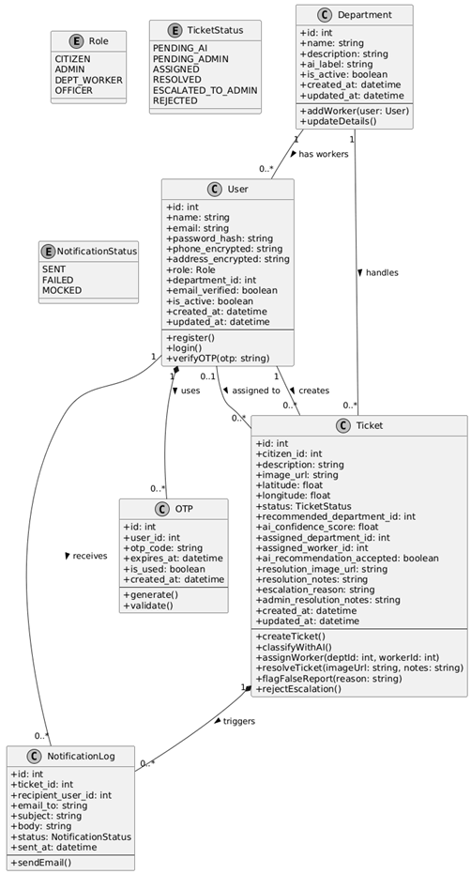
- Object Diagram
Content & Structure
The Object Diagram displays a real-world snapshot of the system at a specific moment in time. This snapshot represents Workflow B & C in motion:
- c1: User (John, a Citizen) has created a ticket (t1: Ticket) about a pothole on Main St.
- The AI recommended the Roads department, and the Admin assigned it to w1: User (Alice, a Dept_Worker).
- The Roads Department (d1: Department) is linked to both the ticket and the worker.
- The ticket assignment automatically triggered a notification (n1: NotificationLog) successfully sent to John (the citizen).
